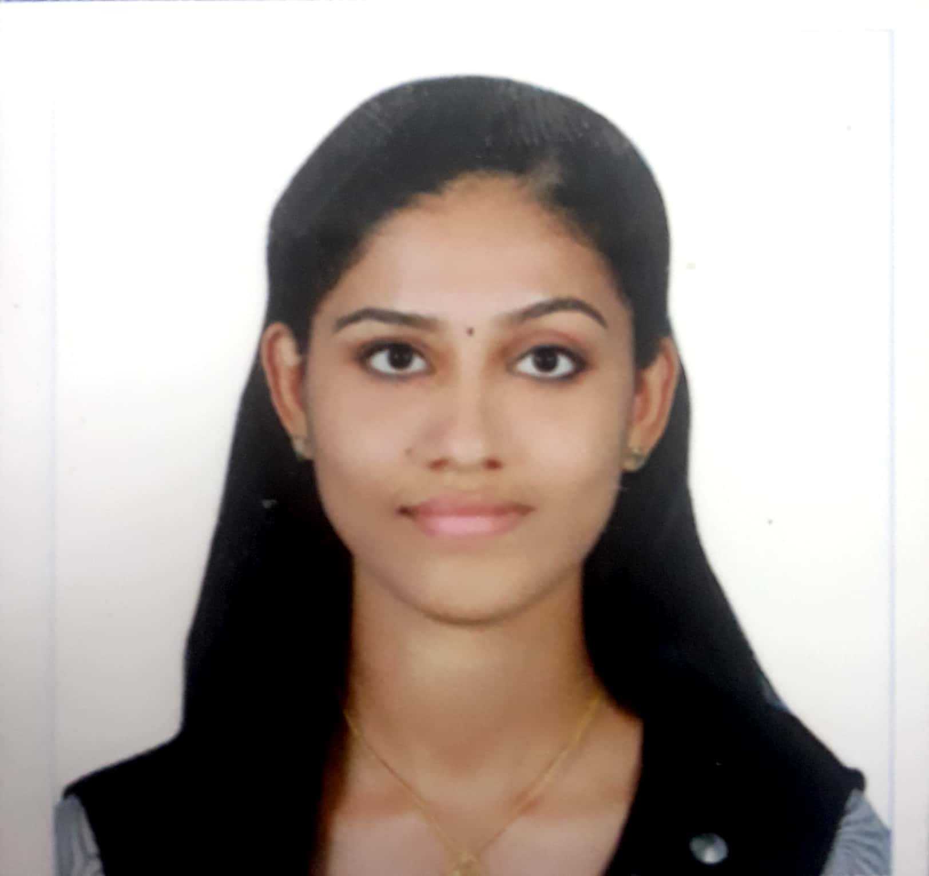

Jesta Jose                            E-mail ID: jestajose398@gmail.com Vadakkumchery house, Contact No: 8075926925

Chalakudy P.O, West chalakudy

Thrissur , Pin: 680307

**CAREER OBJECTIVE:**

* I like to use my skills in the best possible way for achieving the company’s goals. I like to be in a position where I can use the knowledge and strength that I have. I want to partake in the growth and success of the company I work for.

**EDUCATION QUALIFICATION:**

● Bachelor of technology in computer science and engineering (KTU)

Sahrdaya College of Engineering and Technology, Kodakara(Cgpa: 7.3 till s6)

* 12th standard from St. Mary’s GHSS Kuzhikattussery, Thrissur (Kerala Higher Secondary Board) with 86. % marks.
* 10th standard from St. Joseph’s EMHSS Aloor (Kerala State Education Board) with 86% marks.

**TECHNICAL SKILLS:**

* Operating systems: Windows 10, Windows 7, Windows XP, Linux
* Languages : Basic concept of C language,Python,Java,C++
* Packages : MS Office, MS Office Excel, MS Project, MS Power point

**PROJECTS**

● IOT based school bus tracking and monitoring(semester 5)

● Steganography(semester 4)

● Restaurant Management system(semester 3)

**SKILLS**

● Strong communication skills

● Self motivation

● Teamwork

● Leadership

ACHIEVEMENTS

● Paper publication in **International Journal of Inventions,** project titled **School bus tracking and monitoring, ISSN NO: 2279 – 543X**

**INTERNSHIPS**

**● 5 days training from ICT Academy of Kerala, Korraty (Internship)**

**● 5 days training on Data science from Livewire, Thrissur (Internship)**

**● 2 days workshop on Basics of machine learning organised by the college.**

**PERSONAL PROFILE:**

Name                                     : Jesta Jose

Sex : Female

Father’s Name                        : Jose V K

Mother’s Name                      : Siji Jose

Nationality                              : Indian

Caste and Community : Christian

Age : 21

Date of Birth                            : 03-11-1998

Hobbies                                    : Watching movies, Drawing, Listening music

Languages Known                    : Malayalam, English, Hindi

**DECLARATION:**

I hereby declare that the above-mentioned information is correct up to my knowledge and I bear the responsibility for the correctness of the above-mentioned particulars.

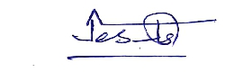 

**Date: Jesta Jose**

**Place: Chalakudy**